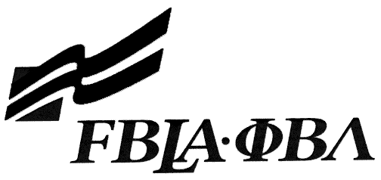 FBLA Statement of Assurance

Illinois State Leadership Conference Entry Form
This form must be completed and attached to each copy of the media. Mail this form to your state adviser not the national office. This form must be mailed or uploaded to your Illinois FBLA State Leadership Conference School Drop Box by February 15, 2017.

Highlight or Circle One: | 3-D Animation | Digital Video Production
 | E-Business | Website Design

Provide the complete URL for E-business, Digital Video Production, and Website Design. These events will be judged online. Make sure the URL link is valid through the State Leadership Conference.

KEY INFORMATION
School:
Website URL Address: (where appropriate—must have full address)
Member(s) Name:
Local Chapter Contact
Name:
Daytime/Cell Number:
Home E-mail:
I/We, the undersigned, attest that the design, creation, and implementation of the event are the original work of the above chapter member(s). I/we agree that this event may be linked, promoted, and used in any way by the national FBLA-PBL, Inc. for purposes of promoting the association. (Typed name is accepted for signature)
Name of Team Member |  | Adviser’s Name
Name of Team Member |  | Name of Team Member
Complete this Document Section for the Above Events if Applicable
Software Used:
Source of Information:
Copyright Notations
Instructions for Running Project:
Template(s) Used (source)

